**All Out of Bubblegum**

**RULES:** Practical Shooting Handbook, Latest Edition **COURSE DESIGNER:** Ben Tarver

|  |  |
| --- | --- |
| **START POSITION:**  Starting with heels on X’s. Handgun is loaded and holstered with wrists below belt.  **PCC START:** Same as handgun with stock on belt, muzzle down range. | |
| **STAGE PROCEDURE**  On start signal engage targets as they become visible, from within the shooting area. | **SCORING**  **SCORING:** Comstock, 28 rounds, 140 points  **TARGETS:** 12 USPSA, 4 steel  **SCORED HITS:** 2Best per USPSA, steel=1A  **START-STOP:**  Audible - Last shot  **PENALTIES:** Per current USPSA rulebok |

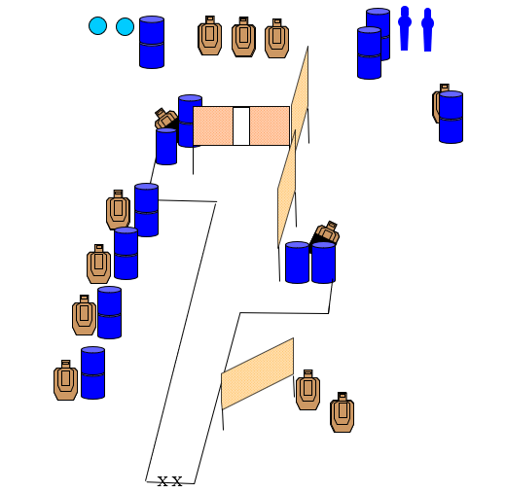

|  |  |  |
| --- | --- | --- |
| **SETUP NOTES**: add hard cover where appropriate |  | **RO NOTES**: |